CAR 129 Air Operations of Foreign Operators

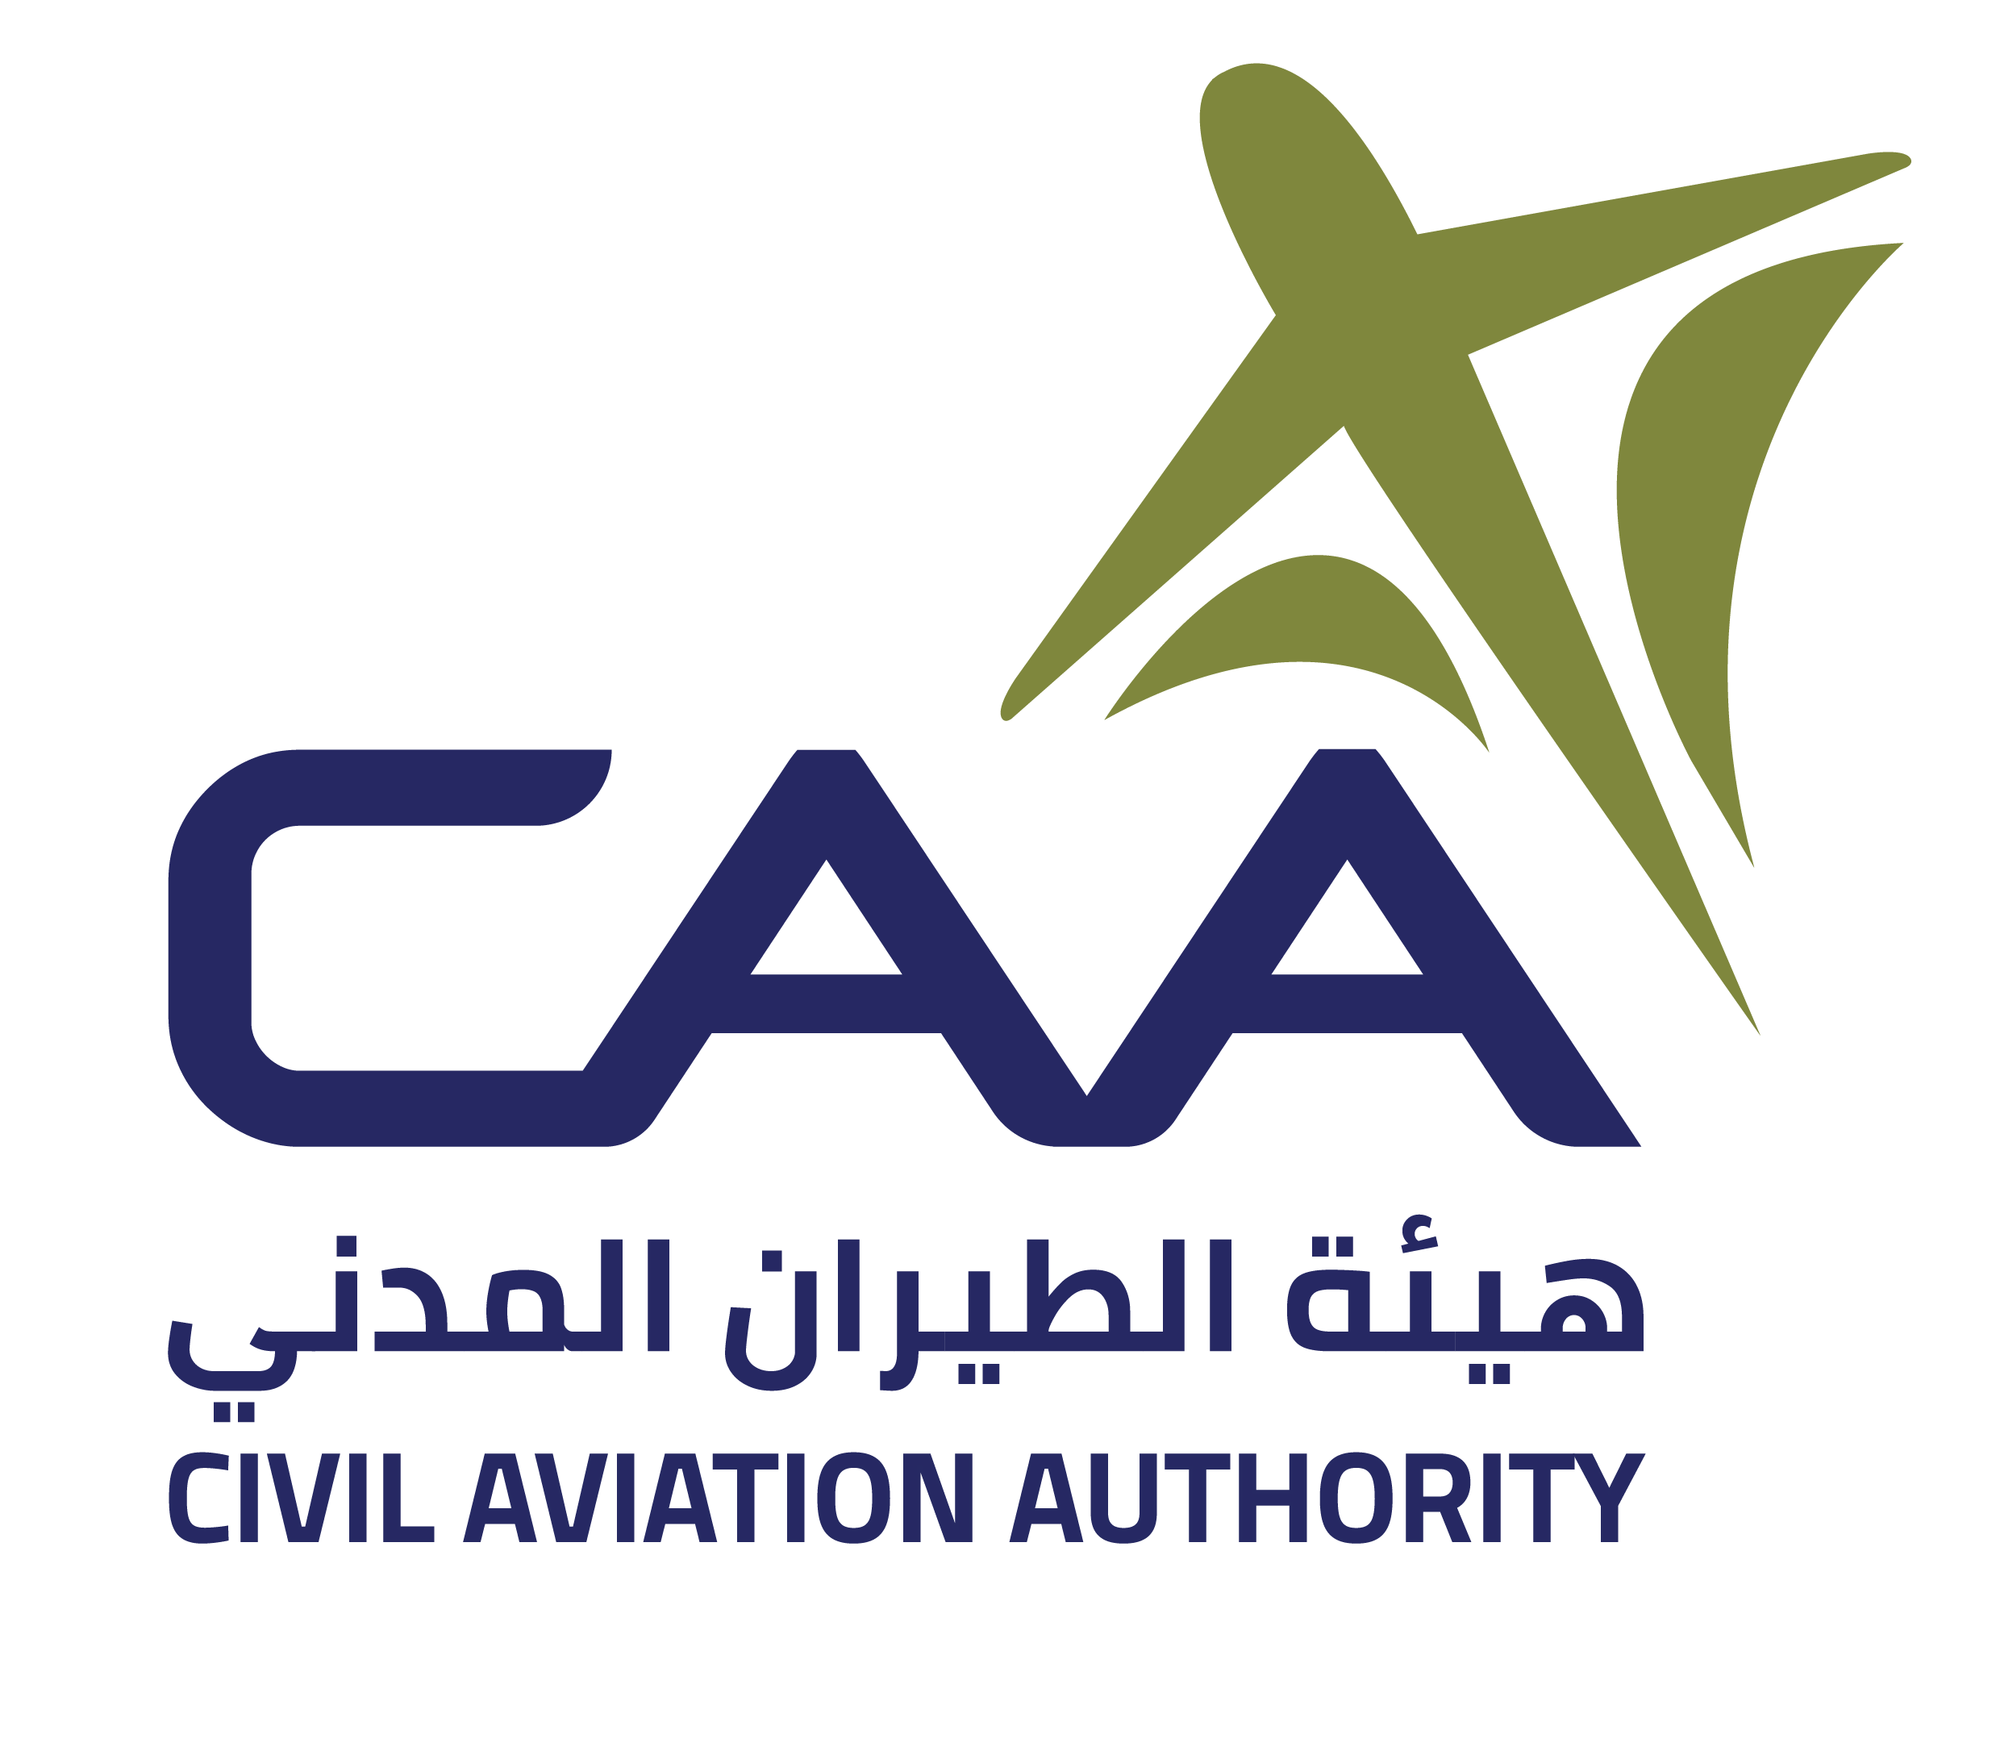

|  |  |
| --- | --- |
| **Types of Operation:** Commercial Air Transport | |
| **Authorisation** | **Operator Name** (2)**:** |
| **DBA Trading name** (3): |
| **State of the Operator** (4): |
| **AOC or equivalent document number** (5)**:**  **i. AOC No.**  **ii. Attached List of Aircraft with Operations Specifications, Date, Aircraft Model,**  **registration, MSN**  **iii. Wet Lease Authorisation No.**  *Note: Authorised registration marks are recorded by the CAA* |
| This authorisation confirms that (Insert Operator Name) (6) has complied with the requirements of CAR 129 and is entitled to perform Commercial Air Transport operations within Oman FIR and the territory of the Sultanate of Oman in accordance with the conditions defined in the Operations Specifications as per latest version | |
| This authorisation is valid whilst the authorised operator remains in compliance with CAR 129 | |
| Subject to compliance with the foregoing condition, this Authorisation will remain valid unless the Authorisation or the Air Operator Certificate issued by the state of the operator has been surrendered, suspended or revoked | |
| **Date of issue** (7) | **Name** (9) **Eng. Hilal Said Al-Hatmi** |
| **Title** (10) **Director Flight Safety** |
| **Authorisation Amendment records** (8) | **Signature** (11) |
| 1. Authorisation Reference Number as issued by the CAA 2. Operator Name 3. Operator trading name, if different, insert ‘DBA’ (doing business as) before the trading name 4. Insert the name of the State of the operator 5. AOC or equivalent document numberand Operating Permits relating to traffic rights may be required in accordance with the bilateral agreement in place between Oman and the State of operator 6. Operators registered name 7. Issue date of the authorisation (DD-MM-YYYY) 8. Authorisation Amendment records (DD-MM-YYYY) 9. Name and signature of CAA representative 10. Title of CAA representative 11. Authorised Signatory of CAA representative | |
| Send completed “Authorisation” and “Specification” Forms to CAA Oman email: ramp.inspection@c[aa.gov.om](mailto:CAR129@caa.gov.om)  This Authorisation shall be carried on board of the aircraft | |

Appendix **1 FO CAR 129-001 Form 1** Authorisation Reference (1) No. **XX/YYYY**

**AUTHORISATION**

FO CAR 129-001 Form 1 R01Page **1 of 1** Revision Date: **01 Oct 2025**

|  |  |  |  |  |
| --- | --- | --- | --- | --- |
| **List of Aircraft** | | | | |
| **SNo** | **Ops Spec Date** | **Aircraft Model** | **Registration** | **MSN** |
| 1 |  |  |  |  |
| 2 |  |  |  |  |
| 3 |  |  |  |  |
| 4 |  |  |  |  |
| 5 |  |  |  |  |
| 6 |  |  |  |  |
| 7 |  |  |  |  |
| 8 |  |  |  |  |
| 9 |  |  |  |  |
| 10 |  |  |  |  |
| 11 |  |  |  |  |
| 12 |  |  |  |  |
| 13 |  |  |  |  |
| 14 |  |  |  |  |
| 15 |  |  |  |  |
| 16 |  |  |  |  |
| 17 |  |  |  |  |
| 18 |  |  |  |  |
| 19 |  |  |  |  |
| 20 |  |  |  |  |
| 21 |  |  |  |  |
| 22 |  |  |  |  |
| 23 |  |  |  |  |
| 24 |  |  |  |  |
| 25 |  |  |  |  |
| 26 |  |  |  |  |
| 27 |  |  |  |  |
| 28 |  |  |  |  |
| 29 |  |  |  |  |
| 30 |  |  |  |  |
| 31 |  |  |  |  |
| 32 |  |  |  |  |
| 33 |  |  |  |  |
| 34 |  |  |  |  |
| 35 |  |  |  |  |
| 36 |  |  |  |  |
| 37 |  |  |  |  |
| 38 |  |  |  |  |
| 39 |  |  |  |  |
| 40 |  |  |  |  |
| 41 |  |  |  |  |
| 42 |  |  |  |  |
| 43 |  |  |  |  |
| 44 |  |  |  |  |
| 45 |  |  |  |  |
| 46 |  |  |  |  |
| 47 |  |  |  |  |
| 48 |  |  |  |  |
| 49 |  |  |  |  |
| 50 |  |  |  |  |

FO CAR 129-001 Form 1 R01Page **1 of 2** Revision Date: **01 Oct 2025**